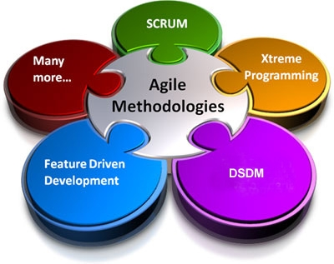

Agile methods SCRUM and DSDM

Yiu Kitman (CIT185753)  
Software Development Life Cycle  
Eric Lam

CONTENT

Introduction 2

DSDM 3

Introduction 3

DSDM puporse 3

The DSDM Development Process 0

DSDM Roles 0

Example if using DSDM 1

SCRUM 1

Introduction 1

Content 1

Elements 1

Roles 1

Artifacts 0

Meetings 0

Example of using SCRUM 1

Benefits and Drawbacks 1

Introduction 1

Scrum 1

DSDM 4

In the Functional Model 4

Compare 6

Conclusion 7

CONTENT 8

# Introduction

It is important that the game industry choose a suitable method for a team , with choosing a wrong method not only the company will lose thousand and billions of money , and also it will lose a lot time produce nothing , so choosing the correct and suitable methodology for the companies becomes very important , in this article I will writing about the benefits and drawbacks of two of the agile methodology which are called “SCRUM” and “DSDM” ,to be able to know about the benefits and drawbacks I will provide some basic information of two methodology which allow us to do the research for this topic, and at the end of this article, I will be comparing two methodology. An image below is to respect to relationship between SCRUM and DSDM.

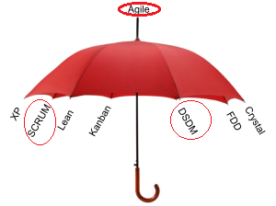

# DSDM

## Introduction

Dynamic systems development method (DSDM) is an [agile](http://en.wikipedia.org/wiki/Agile_management) project delivery framework, primarily used as a [software development method](http://en.wikipedia.org/wiki/Software_development_methodology) , in this paragraph I will just to shoot bullets , if you are interesting about DSDM please goto the following website: <http://www.codeproject.com/Articles/5097/What-Is-DSDM>

## DSDM puporse

According to (The Advantages and Disadvantages of Agile Development Software Methods)

• Focus on what the business needs

• Deliver work on time

• Collaborate effectively

• Never, ever compromise quality

• Build the project incrementally using solid foundations

• Develop the project iteratively

• Continuously communicate with clarity

• Demonstrate control

## The DSDM Development Process

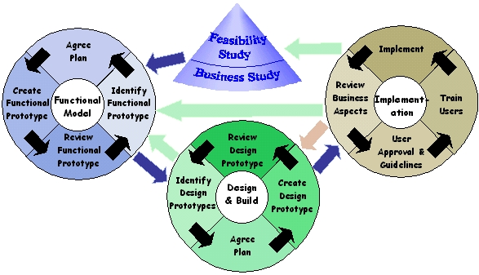

According to **(Marc Clifton, J. Dunlap. 2003)**

The DSDM development process consists of 7 phases. The project flow may move between the different phases in the directions indicated by the arrows above.

The blue arrows in the diagram indicate the normal forward direction of project flow.

The green arrows indicate directions that may be taken as necessary under normal circumstances. For example, if the team has finished a "Design and Build" iteration, but the system cannot be released until another area's functionality has been defined and it has been built, the project flow may go back to the "Functional Model" iteration to complete that area.

The red arrow represents a direction that is only taken if the project has been found to not meet the required functionality.

* Pre-Project

The pre-project phase is not strictly defined. It occurs before the project officially begins. In this stage, the project is conceptualized, and the decision is made to start the project.

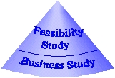

* Functional Model

In this stage, functional prototypes of the system are made and reviewed. A functional prototype is a prototype of the functions the system should perform and how it should perform them.

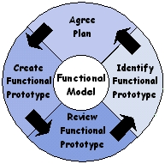

* Design And Build

In this stage, the product is designed and developed in iterations. In each iteration a design model is made of the area being developed, and then that area is coded and reviewed.

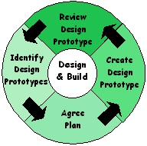

* Implement/Deploy/Maintain

In the last phase, the product is wrapped up, documentation is written, and a review document is drawn up, comparing the requirements with their fulfillments in the product. The users are trained in how to use the system, and the users give approval to the system.

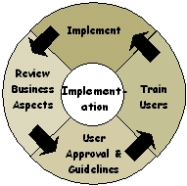

* Post-Project - Maintenance

After the product is created, maintenance will inevitably need to be performed. This maintenance is generally done in a cycle similar to the one used to develop the product.

## DSDM Roles

According to **(Marc Clifton, J. Dunlap. 2003)**

DSDM defines several key roles that should be filled by members of the team:

* Ambassador
* Visionary business goals.
* Advisers
* Technical Coordinator
* Executive Sponsor
* Project Manager
* Team Manager
* Senior Developer
* Facilitator.
* Scribe

## Example if using DSDM

You are trying to sell you game idea, so first the business people will start and do some study and see does the game idea work or some ideas why some of the similar games would be fail or success, If it works it will go into the start create the prototype it will be looping until everyone agree the plan. After that the designer will that making a plan and setup timetables this also will be keep looping until it can be finish. And the large stages are to design the game, if something goes wrong at that stage people will go back and do revision again until the game is finish.

# SCRUM

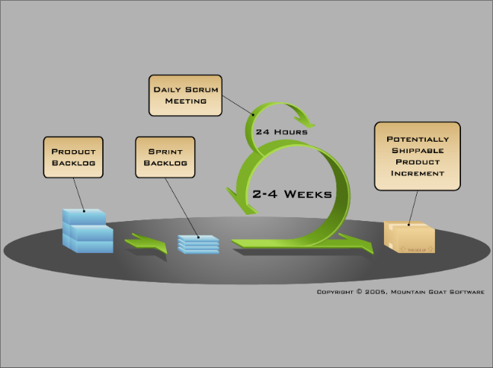

## Introduction

Same as above the paragraph , I will first talk about the history of Scrum and how does scrum work or in other word what element does scrum have after that I will talk about the advantage and disadvantage of Scrum , and of course at the end give an example that how does scrum work.

## Content

**(Wikipedia:Scrum(software development))** Scrum is an iterative and incremental agile software development framework for managing product development.

**NEW Intro to Agile Scrum in Under 10 Minutes - What is Scrum?(2012)** would indicate that In Scrum there are three few elements: roles, meetings, artifacts, and the different roles are: Product Owner, Team, and [Scrum Master](http://scrummasterchecklist.org/pdf/ScrumMaster_Checklist_12_unbranded.pdf).

## Elements

### Roles

* Product Owner

The Product Owner responsibility is to remove any [impediments](http://scrummethodology.com/scrum-impediments/) that obstruct a team’s pursuit of its sprint goals.

* [Scrum Master](http://scrummasterchecklist.org/pdf/ScrumMaster_Checklist_12_unbranded.pdf)

The Scrum Master has to make sure that the project is on track , any commutate with Product Owner that can tell him what can be done and what not

* Team

And the last role in SCRUM is the team, the team is responsible for completing work.

### Artifacts

* Product Backlog

The collection of all these user-stories is called product backlog. The user-stories are kind of feature requests from the customers, executives, or even other team members that have been written from the perspective of the end –user.

* Release Backlog

The product owner will identify the user-stories they want to put into this release. After he decided what he want to put in the release he will put it into the release backlog.

* Sprint Backlog

Which take from the release backlog and split it up into several of these, One of the most important things remember about sprints is that the goal each sprint is to get a subset of the release backlog to a ship-ready state ,so at the end of each sprint.

Burndown chart

The burn down chart is the number one reason for Scrum’s popularity, because this ensure a project is progressing smoothly by this visibility tool. The burn down chart provides a day-by-day measure of amount of work that remains in a given sprint or release. The burn down chart provides a day-by-day measure of the amount of work that remains in a given sprint or release

### Meetings

* The sprint meeting

Every iteration starts with a sprint planning meeting. The product owner holds a conversation with the team and decides which stories are highest in priority, and which ones they will tackle first. Stories are added to the sprint backlog, and the team then breaks down the stories and turn them into tasks.

* Daily Scrum

**(wikihow:Run a Daily Scrum)**The daily scrum is also known as the daily standup meeting. This serves to tighten communication and ensure that the entire team is on the same page. Each member goes through what they have done since the last standup, what they plan to work on before the next one, and outline any obstacles.

* Sprint retrospective meeting

Finally, after a sprint, the scrum master meets with the team for a retrospective meeting. They go over what went well, what did not, and what can be improved in the next sprint. The product owner is also present, and will listen to the team lay out the good and bad aspects of the sprint. This process allows the entire team to focus on its overall performance and identify strategies for improvement. It is crucial as the Scrum Master can observe common impediments and work to resolve them.

## Example of using SCRUM

1. We get all the request from the customers, executives, or even team members and write to the user stories

2. After collected all the user stories and put it into product backlog

3. Then the product owner we decide which user stories are going to put into the product

4. The Scrum master sets up meeting, monitors the work being done and facilitates release planning

5. The Team will start building the product building the sprint

6. Redo until finish

# Benefits and Drawbacks

## Introduction

In this selection I will be writing about the benefits and drawbacks of two agile methodology from my own perspective and also from the perspective of game industry, after that I will do a conclusion this selection.

## Scrum

**(SBGames2010)** said SCRUM is become popular is because SCRUM can minimal as possible delays and mistakes. Although some people may already have knowledge in software development, there are specific features of game development that can prevent the success of great games. This results on major problems in project management. The use of this methodology is to focus on game development to avoid those problem.

|  |  |  |
| --- | --- | --- |
| **Statement** | **Reason / Explain** | **Website and author** |
| **(intland. 2013.)**corrections frequently, and collect feedback from clients as quick as possible | To allow the company to maximum their profits must collect feedback from clients as quick as possible , because firstly**(**[**National Chiao Tung University IR**](http://ir.lib.nctu.edu.tw/)**,2013)**  Customer satisfaction was positively was positively associated with relationship, secondly relationship quality had significantly positive effect on both repurchase intention and customer profitability , in other word the higher the customer satisfaction the more people will by the game | For the game companies, they will release an alpha test and beta test for some player to play test there game so they can get feedback. |
| **(Clinton Keith)**The Scrum Approach four elements to the Teams including :Cross-discipline, Self-management, Self-organization, True leadership | **Cross-discipline**  Enables teams to deliver features and mechanics that have clear value to customers and stakeholders  **Self-management:**  Because enables teams to select the amount of work they can commit to every sprint and complete that work through whatever means they find appropriate.  **Self-organization:**  Enables teams to have a degree of authority and responsibility to select their membership  **True leadership**  Provides leadership focused on mentoring and facilitation to free the best performance possible from the team |  |
| **(Clinton Keith. 2013)** Experience  "At the heart of scrum is the interaction of the team. A daily meeting around the task board is interactive, vibrant, collaborative, visual, and tactile. It is a visual way of showing the goal the team is striving toward and the progress they are making. They, each and every member of the team, are peers.  "They own the goal. It's a team effort. They gather around the board to align themselves with each other, to honor others' contribution to the effort, and to course-correct when they are missing the mark. They argue, discuss, share, learn, continually improve, celebrate, boost each other up, and create solutions.  "There is another thing that Scrum does for the team: It creates transparency. Since Scrum depends on collaboration and continual forward progress, problems are addressed by the team as they crop up instead of dealing with them later or covering the problem under a layer of 'spin.'  "A structured, militant environment will never create a team. A team works together toward a shared goal. A group works together toward a goal given to them. Scrum is messy and noisy. It lives, it breathes, it stretches, it morphs, and it expands. Interaction is the heart of the team. The heart of Scrum is the team." | To allow the company to maximum their profits there must be able a way that all team member can visual the same goal, and also create transparency, avoid create a structured militant environment. | The game complies would need the have a way to a visual way of showing the goal the team is striving toward and the progress they are making. And do not create a structured, militant environment |
| **(johnstok. 2008)**Based on my experience, I would say the key features of Scrum are:   * High visibility of progress. * Regular feedback from customer. * Predictable rhythm. * Measurable productivity (via burndown, velocity, etc.). * Cross-functional, self-organising teams. * Inspect and adapt. * Low bureaucratic overhead (meetings, documentation, etc.). * Emphasis on face-to-face communication.   And these features lead to the following benefits:   * Project can respond easily to change. * Problems are identified early. * Customer gets most beneficial work first. * Work done will better meet the customer’s needs. * Improved productivity. * Ability to maintain a predictable schedule for delivery. | To allow the company to maximum their profits you would need to make sure it reaches the left points to increase the customer satisfaction. |  |

## DSDM

|  |  |  |
| --- | --- | --- |
| **Statement** | **Reason / Explain** | **Example of using in game industry** |
| early implementation to business problems | To allow the company to maximum their profits, it is important the early implement to business problem | These means the game companies would need to study the business from other game companies’ aspects of the project before starting the project. |
| risk of building the wrong computer system is reduced | To allow the company to maximum their profits is try to avoid building the wrong computer system | The Feasibility Study phase would need to be study the other game project before starting the project which reduced building the wrong system |
| the final system is more likely to meet the users’ real business requirements | To allow the company to maximum their profits, the system must meet the users need. | In these three phase Implement/Deploy/Maintain the user would need to be keep testing the system |
| IT professionals and end users become partners | To allow the company to maximum their profits, it is important that the IT professionals and end user become partners, because understanding what the end user needs are important. | In these three phase Implement/Deploy/Maintain the user would need to be keep testing the system and give feedback to the IT professionals |
| the users will be better trained, since their representatives will define and co-ordinate the training required | To allow the company to maximum their profits it is important to define a system how to train up the user | In DSDM of these three phase Implement/Deploy/Maintain the game players are trained in how to use the system, and the users give approval to the system. |
| implementation is more likely to go smoothly, because of the co-operation of all parties concerned in development | To allow the company to maximum their profits, making sure all parties concerned most co-operation in the development | In the Functional Model Phase all the development will sit down and chart together. |
| Active user involvement is imperative. | To allow the company to maximum their profits, the active user must be involvement to the project | The active player must able to do some play testing in the alpha and beta stage of the game. |
| DSDM teams must be empowered to make decisions.  Iterative and incremental development is necessary to converge on an accurate business solution. Initial design constantly improved | To allow the company to maximum their profits, since there no decisions have to be verified, so making the development process more efficient is important. | The team will have power the make decisions every couple months/weeks. |
| The focus is on frequent delivery of products. | To allow the company to maximum their profits, the company should frequent delivery the product so they can get feedback as soon as possible | The team will need to people to test put the game every couple months/weeks. |
| Business suitability is the essential criterion for acceptance of deliverables. Meets business goals and objectives too. | To allow the company to maximum their profits, we must measure how suitability is it for the company | The game companies would need to see how much download and feedback they have from the player |
| **Disadvantage** |  |  |
| Excessive time spent on decision making | Spending on too much time make decision and not doing the project will increase the development profits | Game companies would need to spent and discussion is that discussion |
| Irreversible increments are developed | Not allow the increase the increments make the game feel bad will decrease the game value | If something feature had been add in the game and recognize it did not work. |
| Team focus on activity rather than delivery of products | Spending on to much about the activity will increase the development profits | The team will have a lot meeting about the business wise not planning how to do the project. |
| Users allocated to the project are “not wanted” by the organisation | Allowing the team members do something they don’t like will increase or something they weak at will increase the development time which also means increase the development profits | The team members will get some jobs that they do not want to do |
| Users get too involved in the project | The player will not want to buy the game since they already played a lot of timer this leads to decrease the sales of the game. | The user will keep testing the project |
| Data structures get too monolithic and inflexible due to rapid prototyping | Not allow change, we either increase the development profits or decrease the sales. | If something runs out the plan there will be no solution to handle that |
| Is costly to implement, as DSDM requires both developers and users to be trained to employ it effectively, therefore it may not be suitable for small organizations or one-off projects. | The companies would need increase the development profits because of training and buying tools. | The use DSMD the companies need to put a money for training and also for the tools |

# Compare

The difference between Scrum and DSDM is scrum is good for project that team size are small(less or equal to 8 person), SCRUM is aimed more for a specific sector (IT sector), the IT and software development industry. Which DSDM can be used in a more wide range in other words mean it’s design is not only for game companies, the DSDM is more for focus on business wise for example find what customer needs, it lessly talk about how to make environment that motivates the employees, and mostly focusing on how to find the maximum value between the user (player) and product (game). If the game company choose to use DSDM and the company will use a lot of time to plan and research about the how the other games fails which employees wouldn’t care about too much, also if a game continuance been test, the value of people buying the game will decrease so game companies would need to balance between testing too much or too less. Comparing to the resource on the internet, The DSDM is more complicated for people to understand how to use since it’s for a different types of industries and there are only a limit of video the 3 best video was published by **(dsdm.org)** which after watching it we still don’t understand what are the biggest advantage that why we should use DSDM instead of SCRUM, also only limit websites give you some examples explain how to use DSDM properly, there even no resource about how game companies can use DSDM this makes huge difficulty to compare between SCRUM and DSDM. On the contrary, SCRUM has a great amount video on YouTube which provide people about how to use scrum and what do you need, even a lot resources on different webpages so every people can understand it more easily. However the Scrum does not have enough solution talking about the business wise. So what I recommend is when you doing the project use SCRUM, but when finding the business value it will be a good choice to use the DSDM.

# Conclusion

In conclude, both method are great for some specific task, SCRUM is created for game companies and DSDM it create for different types of companies in the world. So when the game companies are creating the game, SCRUM is more suitable for game companies work with because the SCRUM focus on more the working flow and how can motivate people in company to do things and make sure the team can reach the aim by choosing a suitable amount of job by themself. However but when publishing a game or finding the value from customer using the DSDM is more suitable for the company because SCRUM does not instruction of how can you publish a game DSDM and to find out the customer value so for that reason DSDM will be more suitable.

# CONTENT

Andre Godoy ´ Ellen F. Barbosa. 2010. Game-Scrum: An Approach to Agile Game Development. [ONLINE] Available at:<http://sbgames.org/sbgames2010/proceedings/computing/short/Computing_short19.pdf>. [Accessed 19 September 14].

Axosoft. (2012). Intro to Agile Scrum in Under 10 Minutes - What is Scrum?),. [Online Video]. 02 February. Available from: <https://www.youtube.com/watch?v=XU0llRltyFM>. [Accessed: 19 September 2014].

wiki. 2014. Scrum (software development). [ONLINE] Available at:<http://en.wikipedia.org/wiki/Scrum_(software_development)>. [Accessed 19 September 14].

my-project-management-expert. The Advantages and Disadvantages of Agile SCRUM Software Development. [ONLINE] Available at: <http://www.my-project-management-expert.com/the-advantages-and-disadvantages-of-agile-scrum-software-development.html>. [Accessed 19 September 14].

wikihow. 2014. How to Run a Daily Scrum. [ONLINE] Available at: <http://www.wikihow.com/Run-a-Daily-Scrum>. [Accessed 19 September 14].

Arvin Cubil Mejillano. 2011. The Advantages and Disadvantages of Agile Development Software Methods. [ONLINE] Available at: <http://ezinearticles.com/?The-Advantages-and-Disadvantages-of-Agile-Development-Software-Methods&id=6600314>. [Accessed 19 September 14].

intland. 2013. What Are the Main Benefits of Using Scrum?. [ONLINE] Available at:<http://www.intland.com/blog/agile/the-main-benefits-of-using-scrum/>. [Accessed 19 September 14].

Clinton Keith. Agile Game Development With Scrum: Teams. [ONLINE] Available at:<http://www.gamasutra.com/view/feature/6040/agile_game_development_with_scrum_.php?print=1>. [Accessed 19 September 14].

johnstok. 2008. What are the major benefits of scrum as a methodology?. [ONLINE] Available at:<http://stackoverflow.com/questions/208442/what-are-the-major-benefits-of-scrum-as-a-methodology>. [Accessed 19 September 14].

Marc Clifton, J. Dunlap. 2003. What Is DSDM?. [ONLINE] Available at:<http://www.codeproject.com/Articles/5097/What-Is-DSDM>. [Accessed 19 September 14].

(dsdm.org).2014.What is DSDM?. [ONLINE] Available at: <http://www.dsdm.org/content/what-dsdm>. [Accessed 19 September 14].